Measuring Units Screen
  - Purpose
    - This screen manages the information of different measuring Units.
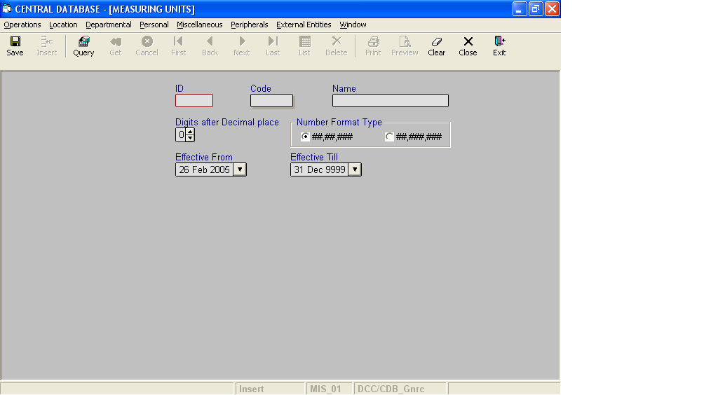

Layout as seen on opening of the Screen
  - Events associated
None
  - Modes
    - It will start in Insert mode.
    - It supports Insert, Query, Retrieve, Browse and List and modes.
  - Field specifications
 | Type | Length | Optional | Insert Mode | Query Mode | BrowseMode
ID | measuring_unit_id | 2 | N | N.A. | Allow | Display
Code | char | 4 | N | Allow | Allow | Allow
Name | varchar | 20 | N | Allow | Allow | Allow
Digits after Decimal Place | TINYINT | 1 | N | Allow | Allow | Allow
Number Format Type | char | 8 | N | Allow | Allow | Allow
Effective From | datetime | 8 | N | Allow | Allow | Allow
Effective Till | datetime | 8 | N | Allow | Allow | Allow
  - Fields
    - ID
      - This is the measuring Unit ID, which uniquely identifies all the measuring units.
      - This field will be automatically generated by the system.
      - The user will be informed of the generated ID as part of the message which will be shown on successful saving of information in Insert Mode.
    - Code
      - This is the code of the measuring unit.
      - It is user defined. It can be changed in Browse Mode.
      - Code of the measuring unit is uniquely defined in the database.
    - Name
      - This is the name of the measuring unit.
      - The name can be changed in Browse Mode.
      - Name of the measuring unit is uniquely defined in the database.

    - Digits after Decimal Place
a) It specifies the number of digits that should be permitted after decimal point for accepting as well as printing values for this unit.
b) It should be greater than or equal to zero and less than or equal to 5.

    - Number Format Type
a) It is used to specify the default printing option that should be used to print the commas before decimals.
- Lacs format type (##,##,###) specifies to print a number like 9,99,99,99,999
- Millions format type (##,###,###) specifies to print a number like 9,999,999,999
b) By Default the radio button with the caption “##,##,###” in the frame titled Number Format Type will be selected.
vi. Effective From
      - This is the date since which a measuring unit is effective.
      - By default, the system will display the current date in Insert Mode.
      - Normally, it should not be a future date. This is the recommendation. System will display a warning, if future date is specified.
      - It cannot be later than the date specified in Effective Till.
    - Effective Till
      - This is the date till which a measuring unit is effective.
      - By default, the system will display 31-Dec-9999 in Insert Mode.
      - Normally, it should not be a past date.
      - It cannot be earlier than the date specified in Effective From.

  - Action Buttons
None
  - Users / User Roles
MSC_Gnrc user is permitted to insert, update, delete and select measuring unit.
  - Other Considerations
None

